Network Layer
Unit 4

1 NETWORK LAYER DESIGN ISSUES
These issues include the service provided to the transport layer and the internal design of the network.
- Store-and-Forward Packet Switching
- Services Provided to the Transport Layer
- Implementation of Connectionless Service
- Implementation of Connection-Oriented Service

1.1 Stores-and-Forward Packet Switching

The host sends the packet to the nearest router. This packet is stored there until it has fully arrived once the link is fully processed by verifying the checksum then it is forwarded to the next router till it reaches the destination. This mechanism is called “Store and Forward packet switching.”

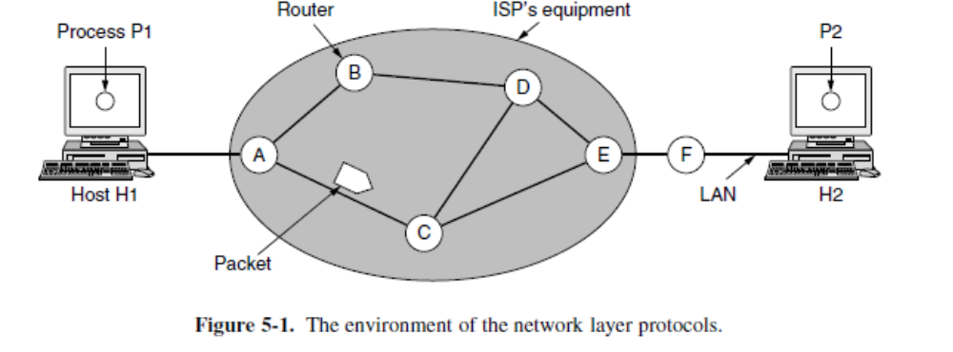

1.2 Services Provided to the Transport Layer
The services need to be carefully designed with the following goals in mind:
- The services should be independent of the router technology.
- The transport layer should be shielded from the number, type, and topology of the routers present.
- The network addresses made available to the transport layer should use a uniform numbering plan, even across LANs and WANs.

Each packet must carry the full destination address, because each packet sent is carried independently of its predecessors. In this view, quality of service is the dominant factor, and without Connections in the network, quality of service is very difficult to achieve, especially for real-time traffic such as voice and video.

1.3 Implementation of Connectionless Service
If connectionless service is offered, packets are injected into the network individually and routed independently of each other. No advance setup is needed. In this context, the packets are frequently called datagrams (in analogy with telegrams) and the network is called a datagram network.

1.4 Implementation of Connection-Oriented Service
To use a connection-oriented service, first we establish a connection, use it and then release it. In connection-oriented services, the data packets are delivered to the receiver in the same order in which they have been sent by the sender. It can be done in either two ways:

Circuit Switched Connection – A dedicated physical path or a circuit is established between the communicating nodes and then data stream is transferred.

Virtual Circuit Switched Connection – The data stream is transferred over a packet switched network, in such a way that it seems to the user that there is a dedicated path from the sender to the receiver. A virtual path is established here. While, other connections may also be using the same path.

2 ROUTING ALGORITHMS

The main function of the network layer is routing packets from the source machine to the destination machine.
Routing algorithm is a process of forwarding of a packet in a network so that it reaches to intended destination. Algorithms can be grouped into two major classes: Non adaptive and Adaptive.
Nonadaptive algorithm (static) | Adaptive Algorithm (Dynamic)
They do not base their routing decisions on any measurements or estimates of the current topology and traffic. | They change their routing decisions to reflect changes in the topology, and sometimes changes in the traffic as well.
Route computed in advance, offline. | Changes routes dynamically.
Ex. Shortest Path Routing, Flooding, Flow based routing. | Ex. Distance Vector Routing, Link state routing

When new connections are established, certain properties are desirable in a routing algorithm:
Correctness: Routing should be done correctly.
Simplicity: Routing should be done in a simple manner.
Robustness: The ability to extend the system over a year.
Stability: Routing algorithm should be stable under all circumstances.
Fairness: Every node connected to the network should get a fair chance to transmit their packets.
Efficiency (Optimality): Optimal in terms of throughput & efficiency, minimizing mean packet delay.

2.1 Shortest Path Algorithm
The idea is to build a graph of the network, with each node of the graph representing a router and each edge of the graph representing a communication line, or link. To choose a route between a given pair of routers, the algorithm just finds the shortest path between them on the graph.
One way of measuring path length is the number of hops.
Dijkstra ‘s Algo and finds the shortest paths between a source and all destinations in the network. Each node is labeled (in parentheses) with its distance from the source node along the best known path.
The distances must be non-negative, as they will be if they are based on real quantities like bandwidth and delay.

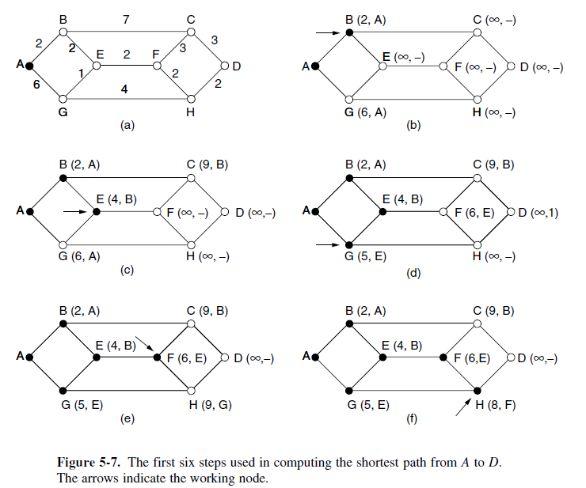

2.2 Flooding
When a routing algorithm is implemented, each router must make decisions based on local knowledge, not the complete picture of the network. A simple local technique is flooding, in which every incoming packet is sent out on every outgoing line except the one it arrived on.

Flooding obviously generates vast numbers of duplicate packets, in fact, an infinite number unless some measures are taken to damp the process.

One such measure is to have a hop counter contained in the header of each packet that is that is decremented at each hop, with the packet being discarded when the counter reaches zero. Ideally, the hop counter should be initialized to the length of the path from the source to destination. If the sender does not know how long the path is, it can be initialized to the worst case, namely the full diameter of the network.

A variant of flooding is called selective flooding partially addresses these by issues by only sending packets to routers in the same direction. In selective flooding the routers don’t send every incoming packet on every line but only on those lines which are going approximately in the right direction.
Flooding always chooses the shortest path because it chooses every possible path in parallel. Consequently, no other algorithm can produce a shorter delay.

2.3 Distance Vector Routing

A distance vector routing algorithm operates by having each router maintain a table (i.e., a vector) giving the best known distance to each destination and which link to use to get there. These tables are updated by exchanging information with the neighbours. Eventually, every router knows the best link to reach each destination.
The distance vector routing algorithm is sometimes called by other names, most commonly the distributed Bellman-Ford routing algorithm.
In distance vector routing, each router maintains a routing table indexed by, and containing one entry for each router in the network. This entry has two parts: the preferred outgoing line to use for that destination and an estimate of the distance to that destination. The distance might be measured as the number of hops or using another metric.
The router is assumed to know the ‘‘distance’’ to each of its neighbours. If the metric is hops, the distance is just one hop. If the metric is propagation delay, the router can measure it directly with special ECHO packets that the receiver just timestamps and sends back as fast as it can.
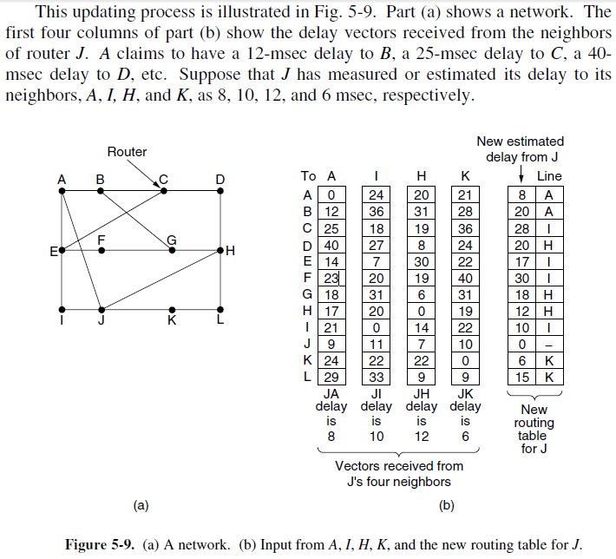

The Count-to-Infinity Problem
The settling of routes to best paths across the network is called convergence. Distance vector routing is useful as a simple technique by which routers can collectively compute shortest paths. No router ever has a value more than one higher than the minimum of all its neighbors. Gradually, all routers work their way up to infinity, but the number of exchanges required depends on the numerical value used for infinity. For this reason, it is wise to set infinity to the longest path plus 1.
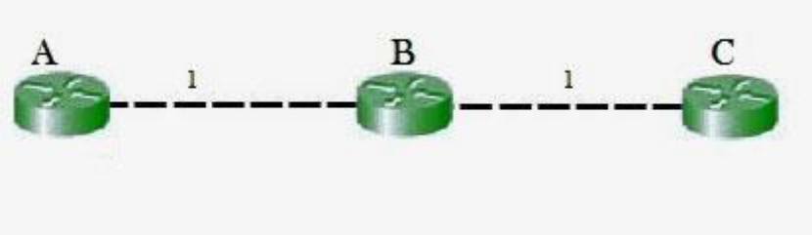
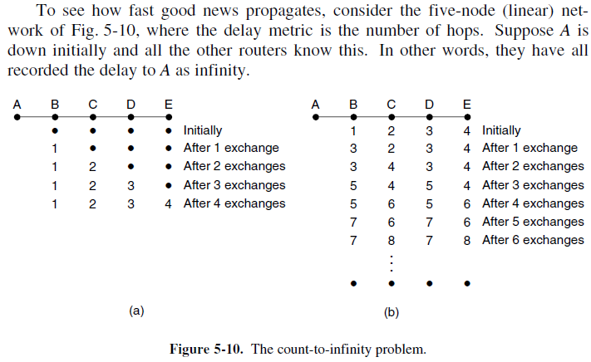
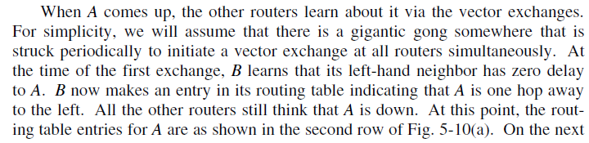
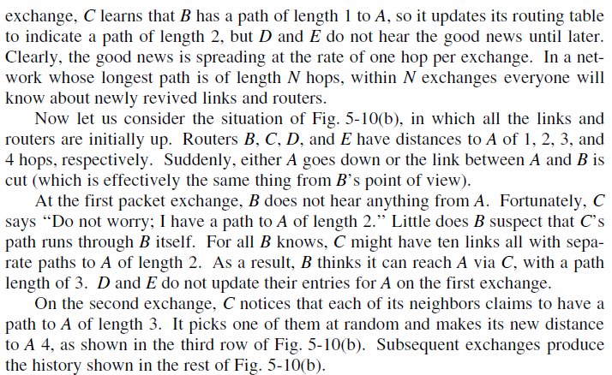
2.4 Link State Routing

Each router must do the following things to make it work:
1. Discover its neighbours and learn their network addresses.
2. Set the distance or cost metric to each of its neighbours.
3. Construct a packet telling all it has just learned.
4. Send this packet to and receive packets from all other routers.
5. Compute the shortest path to every other router.
Then Dijkstra’s algorithm can be run at each router to find the shortest path to every other router.

1. Learning about the neighbours:
When a router is booted, its first task is to learn who its neighbours are. It accomplishes this goal by sending a special HELLO packet on each point-to-point line. The router on the other end is expected to send back a reply giving its name.
These names must be globally unique because when a distant router later hears that three routers are all connected to F, it is essential that it can determine whether all three mean the same F.
When two or more routers are connected by a broadcast link (e.g., a switch, ring, or classic Ethernet), the situation is slightly more complicated.

2. Setting Link cost: The link state routing algorithm requires each link to have a distance or cost metric for finding shortest paths. The cost to reach neighbours can be set automatically, or configured by the network operator. The most direct way to determine this delay is to send over the line a special ECHO packet that the other side is required to send back immediately. By measuring the round - trip and dividing it by two, the sending router can get a reasonable estimate of the delay.

3. Building Link state packets
The packet starts with the identity of the sender, followed by a sequence number and age (to be described later) and a list of neighbours. The cost to each neighbor is also given. An example network is presented

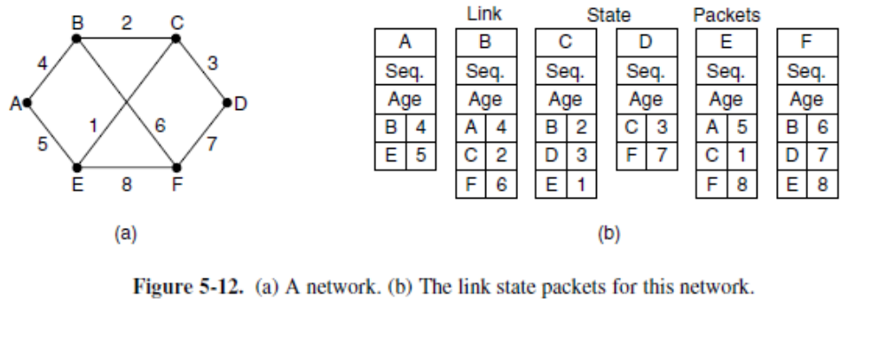

4. Distributing the Link State Packets
All of the routers must get all of the link state packets quickly and reliably. The fundamental idea is to use flooding to distribute the link state packets to all routers. To keep the flood in check, each packet contains a sequence number that is incremented for each new packet sent.
When a new link state packet comes in, it is checked against the list of packets already seen. If it is new, it is forwarded on all lines except the one it arrived on. If it is a duplicate, it is discarded. If a packet with a sequence number lower than the highest one seen so far ever arrives, it is rejected as being obsolete as the router has more recent data.
Problems:
1) If a router ever crashes, it will lose track of its sequence number. If it starts again at 0, the next packet it sends will be rejected as a duplicate.
2) If a sequence number is ever corrupted and 65,540 is received instead of 4 (a 1-bit error), packets 5 through 65,540 will be rejected as obsolete, since the current sequence number will be thought to be 65,540.
Solution:
The solution to all these problems is to include the age of each packet after the sequence number and decrement it once per second. When the age hits zero, the information from that router is discarded.
Normally, a new packet comes in, say, every 10 sec, so router information only times out. The Age field is also decremented by each router during the initial flooding process, to make sure no packet can get lost and live for an indefinite period of time (a packet whose age is zero is discarded).
3 CONGESTION CONTROL
What is congestion?
A state occurring in network layer when the message traffic is so heavy that it slows down network response time.

Factors Causing Congestion:
1. Many input lines demanding the same output lines.
2. Slow receiver and fast sender.
3. Low bandwidth line can also cause congestion.
4. Traffic is bursty.
5. Vast number of duplicate packets may cause the congestion.

Effects of Congestion
- As delay increases, performance decreases.
- If delay increases, retransmission occurs, making situation worse.
Congestion control algorithms
- Congestion Control is a mechanism that controls the entry of data packets into the network, enabling a better use of a shared network infrastructure and avoiding congestive collapse.
- Congestive-Avoidance Algorithms (CAA) are implemented at the TCP layer as the mechanism to avoid congestive collapse in a network.
- There are two congestion control algorithm which are as follows:

1. Leaky Bucket Algorithm
2. Token Bucket Algorithm

Leaky Bucket Algorithm
- The leaky bucket algorithm discovers its use in the context of network traffic shaping or rate-limiting.
- A leaky bucket execution and a token bucket execution are predominantly used for traffic shaping algorithms.
- This algorithm is used to control the rate at which traffic is sent to the network and shape the burst traffic to a steady traffic stream.
- The disadvantages compared with the leaky-bucket algorithm are the inefficient use of available network resources.
- The large area of network resources such as bandwidth is not being used effectively.
Let us consider an example to understand
- Imagine a bucket with a small hole in the bottom. No matter at what rate water enters the bucket, the outflow is at constant rate. When the bucket is full with water additional water entering spills over the sides and is lost.

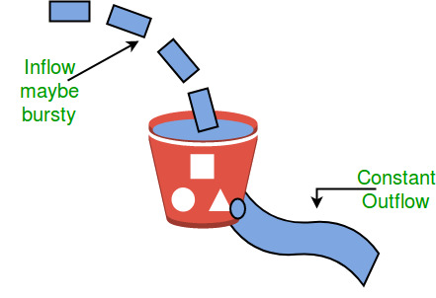

Similarly, each network interface contains a leaky bucket and the following steps are involved in leaky bucket algorithm:
- When host wants to send packet, packet is thrown into the bucket.
- The bucket leaks at a constant rate, meaning the network interface transmits packets at a constant rate.
- Bursty traffic is converted to a uniform traffic by the leaky bucket.
- In practice the bucket is a finite queue that outputs at a finite rate.

Advantages:
1. Reduces the chances of congestion.
Token bucket Algorithm
- The leaky bucket algorithm has a rigid output design at an average rate independent of the bursty traffic.
- In some applications, when large bursts arrive, the output is allowed to speed up. This calls for a more flexible algorithm, preferably one that never loses information. Therefore, a token bucket algorithm finds its uses in network traffic shaping or rate-limiting.
- It is a control algorithm that indicates when traffic should be sent. This order comes based on the display of tokens in the bucket.
- The bucket contains tokens. Each of the tokens defines a packet of predetermined size. Tokens in the bucket are deleted for the ability to share a packet.
- When tokens are shown, a flow to transmit traffic appears in the display of tokens.
- No token means no flow sends its packets. Hence, a flow transfers traffic up to its peak burst rate in good tokens in the bucket.

Need of token bucket Algorithm:-

The leaky bucket algorithm enforces output pattern at the average rate, no matter how bursty the traffic is. So in order to deal with the bursty traffic we need a flexible algorithm so that the data is not lost. One such algorithm is token bucket algorithm.

Steps of this algorithm can be described as follows:

- In regular intervals tokens are thrown into the bucket. ƒ
- The bucket has a maximum capacity. ƒ
- If there is a ready packet, a token is removed from the bucket, and the packet is sent.
- If there is no token in the bucket, the packet cannot be sent.

Let’s understand with an example,

In figure (A) we see a bucket holding three tokens, with five packets waiting to be transmitted. For a packet to be transmitted, it must capture and destroy one token. In figure (B) we see that three of the five packets have gotten through, but the other two are stuck waiting for more tokens to be generated.

Ways in which token bucket is superior to leaky bucket: The leaky bucket algorithm controls the rate at which the packets are introduced in the network, but it is very conservative in nature. Some flexibility is introduced in the token bucket algorithm. In the token bucket, algorithm tokens are generated at each tick (up to a certain limit). For an incoming packet to be transmitted it must capture a token and the transmission takes place at the same rate. Hence some of the busty packets are transmitted at the same rate if tokens are available and thus introduces some amount of flexibility in the system.

4 Quality of Service:
Quality of Service (QoS) is basically the ability to provide different priority to different applications, users, or data flows, or in order to guarantee a certain level of performance to the flow of data.
QoS is basically the overall performance of the computer network. Mainly the performance of the network is seen by the user of the Network.
Let us know first take a look at the characteristics of the Flow:

Flow Characteristics
Given below are four types of characteristics that are mainly attributed to the flow and these are as follows:
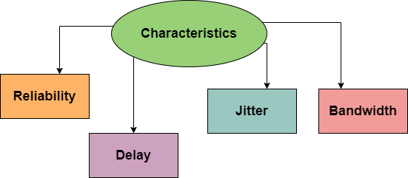

Reliability
It is one of the main characteristics that the flow needs. If there is a lack of reliability then it simply means losing any packet or losing an acknowledgement due to which retransmission is needed.
Reliability becomes more important for electronic mail, file transfer, and for internet access.

Delay
Another characteristic of the flow is the delay in transmission between the source and destination. During audio conferencing, telephony, video conferencing, and remote conferencing there should be a minimum delay.

Jitter
It is basically the variation in the delay for packets that belongs to the same flow. Thus Jitter is basically the variation in the packet delay. Higher the value of jitter means there is a large delay and the low jitter means the variation is small.

Bandwidth
The different applications need different bandwidth.

